**Term Project Phase 2 - Process Discovery**

**Syed Farhan Jafri (21L-6074)  
Shaaf Salman (21L-6083)  
Laiba Habib (21L-6102)  
Abdul Hadi (21L-6077)**

**Process Discovery Methods**

The main process discovery methods that were used were Evidence-Based Discovery and Interview-Based Discovery.

The Evidence-Based Discovery mainly consisted of all three Document Analysis, Observation and Automated Process Discovery.

During the document analysis stage, the main documents that were read through or analyzed was the application form which stated the requirements/needs of filling an application and what other supporting documents are needed to apply for a new/renewal of a passport. Other documents included guidelines and a policy manual for the passport office. These were reviewed to identify processes and requirements.

During the Observation stage, some time was spent during office hours to figure out a pattern of the processes and establish a sequence of steps of each process. The mass and workers were observed to see their work. For example, when a new customer came to apply for a new passport. They first had to fill an application form and provide the required documents to a handler assigned to them. The assigned officer would verify the documents, payment and other details and then approve the form. The application was then forwarded to a manager who was to conduct an interview of the applicant in order to approve them for a passport. Once approved, the application was signed and an approval sent to the printing facilities to produce said passport.

During the Automated Process Discovery, one of our group members, Shaaf, went and applied for the renewal of his passport. After days of hustle and learning the processes through the hectic busy schedule of the office. His passport was finally renewed after almost 2 months of appointments and waiting. During this time, he learned all the steps involved and processes involved.

During the Interview-Based discovery, an interview was conducted of an officer/handler. We could not get access to a higher-level officer so had to settle for an application officer. An interview of 5-7minutes was conducted during which a present questionnaire was asked and some on the spot questions were asked. An external manager was also interviewed and the process learned. The questionnaire and response are attached below as they are hand written.

**Evidence**

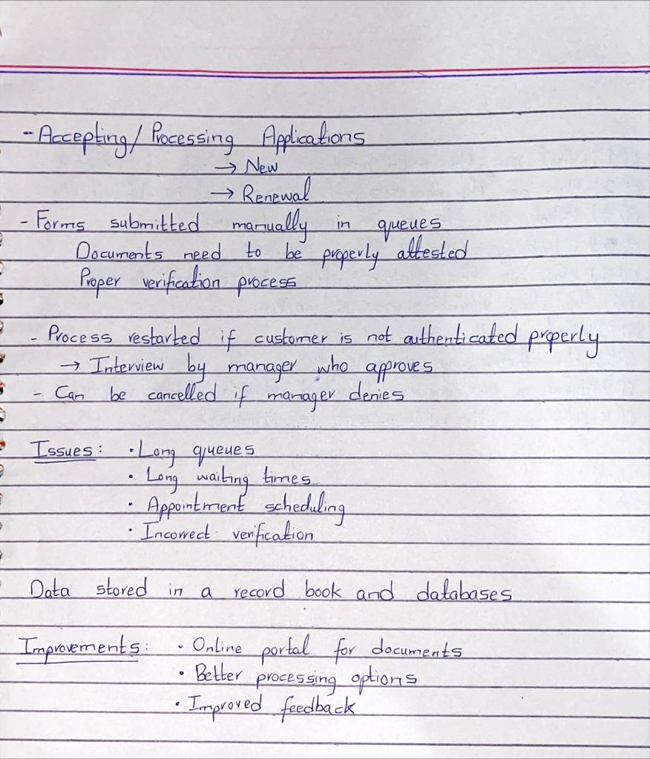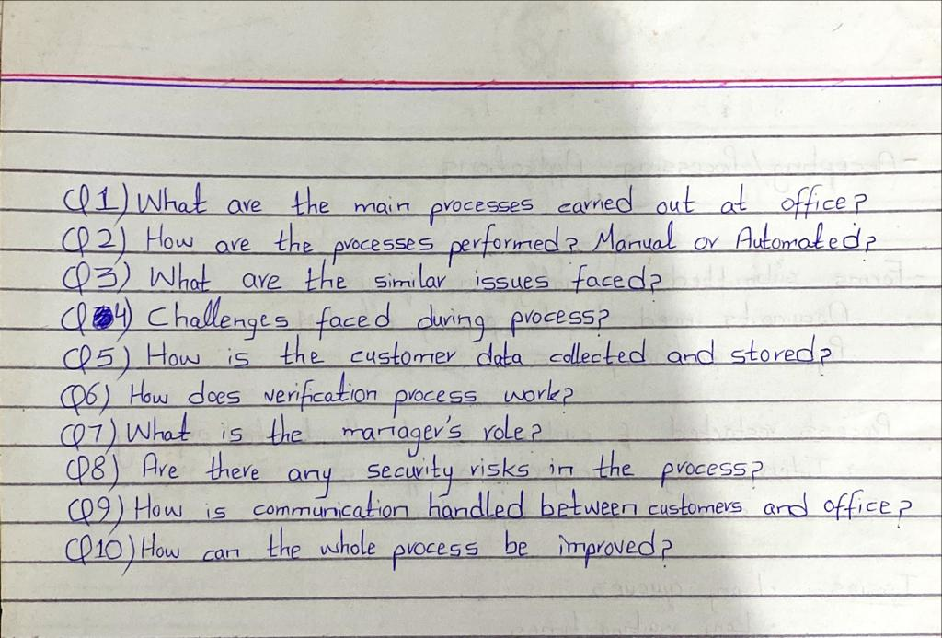**Interview Questionnaire and Responses**

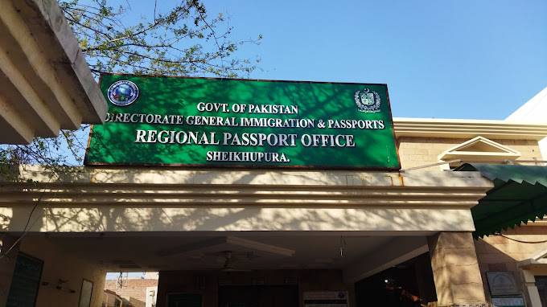**Visit to the Office – Sheikhupura Branch**

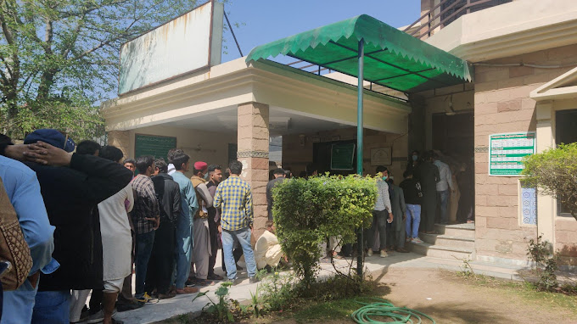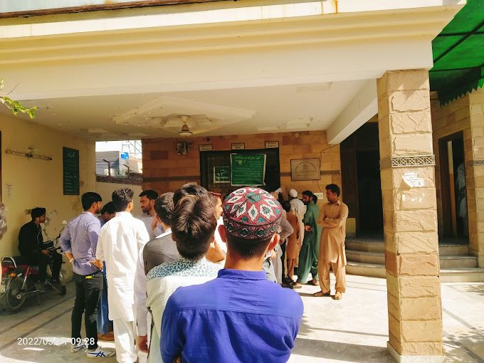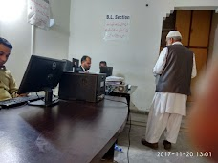

**Abstract of Extracted Process**

**Step 1:**

Applicants are required to submit the passport fee at the National Bank of Punjab against a hardcopy slip. This slip includes essential details such as the applicant's CNIC, passport duration, pages number, duration, urgent/regular, and CNIC/Bay form. The process of submitting the slip at the bank can be time-consuming as there is only one bank available, resulting in long queues and delays.

**Step 2:**

Once the fee is submitted, applicants must obtain a token number from an official agent outside the passport office. Obtaining a token can be challenging without offering bribes, and the process can take up to 45 minutes.

**Step 3:**

After obtaining the token, applicants need to get into a queue for photography. Counter 1 takes the applicant's photo, and counter 2 generates a token number with the details of the bank slip on a single piece of paper that will be used throughout the process.

**Step 4:**

Applicants are required to attest their documents on a counter that works on a sequence of the slip generated by photograph counter 2. The applicant's file is completed at this counter, and they must sign the documents.

**Step 5:**

After completing the document attestation process, applicants must face an interview with the interviewing manager, who asks basic questions about personal details such as profession, education, purpose of passport, etc. Applicants are required to submit their documents at this stage.

**Step 6:**

After the interview, applicants must wait for a certain number of days, depending on the type of passport they have applied for. They are scheduled to wait in a queue to receive their passport.

**AS-IS BPMN Models**

Files Attaches